1. Server Error is usually thrown out of our app and there are many causes and some are:
   1. NullPointerException.
   2. IlligalArgument Exception.
   3. Or any runtime exception.
2. 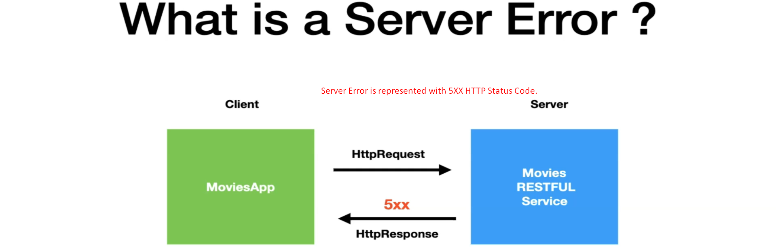
3. Fault response is kind of response that happens kind of network issue.
4. Let’s say a request is made and a connection is made b/w client and the server.
5. Typically, the fault response means
   1. Either the connect was close abruptly or
   2. Some kind of network failure caused the connection to close.